**Chapter 1 - Heat Capacity and**

**Modes of Heat Transfer**

**All Lectures Uploaded on YouTube:**

[**https://tinyurl.com/fkm10-physics**](https://tinyurl.com/fkm10-physics)

**Heat Capacity** 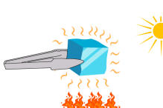

Heat capacity is the amount of heat energy required to raise the temperature of an object or substance by 1°C (or 1 K), regardless of its mass.

**Formula:**

$C=\frac{Q}{ΔT}$

Where:

C = Heat capacity

Q = Heat energy (Joules)

ΔT = Change in temperature (°C

or K)

**SI Unit:**

Joule per degree Celsius (J/°C) or Joule per Kelvin (J/K) **Note:**

● Heat capacity depends on the mass and type of substance.

● It is an extensive property, meaning it changes with the amount of substance.

**Specific Heat Capacity**

**Specific Heat Capacity** is the amount of **heat energy** required to raise the temperature of **1 kilogram of a substance by 1°C (or 1 K)**.

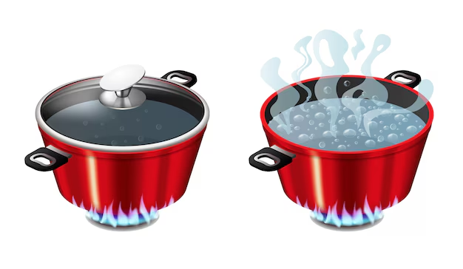

*Formula:*

$Q=mcΔT$

Where:

● Q = Heat energy (Joules)

● m = Mass (kg)

● c = Specific heat capacity

● ΔT= Change in temperature (°C or K); tfinal - tinitial

**SI Unit:**

● **Joule per kilogram per Kelvin (** J kg-1K-1)

***Other Common Units:***

● J/kg°C - Joules per kilogram per degree Celsius

● J/g°C - Joules per gram per degree Celsius

***Important Points:***

● Different materials have different specific heat capacities.

● Substances like water have a high specific heat capacity:

**4186 J/kg°C**

➤ That’s why it heats up and cools down slowly. These substances retain heat for a longer time and can be used for controlling temperature.

● Substances with **low specific heat** (like metals) heat up quickly, as they require less heat, and are also good conductors of heat. These materials heat up and cool down quickly.

**Examples of Specific Heat Capacities:**

| **Substance** | **Specific Heat Capacity (J/kg·°C)** |
| --- | --- |
| Water | 4186 |
| Ice | 2100 |
| Copper | 385 |
| Iron | 450 |
| Aluminium | 900 |
| Lead | 130 |

**Uses of Large Specific Heat of Water:**

***A. Temperature Variation in Land and Coastal Areas:***

● The specific heat of dry soil (800 J/kg·K) is smaller than that of water.

● It is about five times smaller than that of water.

● It is why land area quickly heats up in summer and temperature rises from around 45°C to 50°C, and also cools down quickly in winter, leading to low temperatures from 5°C to 0°C.

● In coastal areas, temperature variation is small, for example in Karachi, average temperature variation is from 19°C to 32°C. 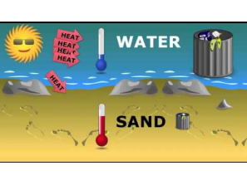

● So, oceans and large lakes absorb a lot of heat from the sun during summer without a rise in temperature.

● In winters, oceans and lakes release heat into the atmosphere.

● **This phenomenon keeps the temperature moderate between summer and winter in coastal areas.**

**B. Maintaining Stability of Ocean and Lake Temperatures:**

● Lakes and oceans heat up and cool down slowly due to high specific heat of water.This prevents changes in the temperature of the lake and oceans and thus provides a suitable environment for aquatic life.

**C. Human Body Temperature Regulation:**

● The human body maintains its temperature at about 37°C. Our body maintains its temperature due to **high specific heat of water**.

**D. Cooling System and Heat Exchangers:**

● Water is used as coolant in power plants, different industrial processes, radiators of cars and other machines.

● Water takes large amount of excess heat from the machines and effectively transfers the heat to the heat exchanger.

● It prevents overheating in the machinery and maintains their efficiency.

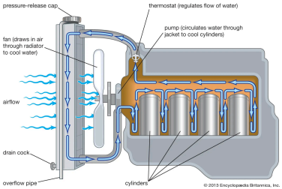

**E. Cooking:**

Water is good for cooking as it heats up slowly and distributes heat evenly. It ensures food cooking without burning.

M**EASURING SPECIFIC HEAT CAPACITY**

***1. Method of Mixtures:***

**For Solids:**

● Heat a known mass of solid to a known temperature.

● Quickly transfer it into a calorimeter containing a known mass of water at a known lower temperature.

● Measure the final equilibrium temperature.

Apply:

Heat lost by solid = Heat gained by water

mscs(Ts−Tf)=mwcw(Tf−Tw)

● Solve for cs (specific heat of solid).

**For Liquids:**

● Heat the liquid or water to a known temperature.

● Mix with another liquid or solid at a different known temperature in a calorimeter.

● Use the same heat gain = heat loss principle to calculate unknown specific heat.

***2. Electrical Heating Method:***

**For Solids and Liquids:**

● Use a heater to supply electrical energy to a known mass of the substance.

● Measure the temperature change over time.

● Use:

Q=VIt = mcΔT

Where:

V = Voltage,

I = Current,

t = Time,

m = Mass,

c = Specific heat,

ΔT= Temperature change Solve for c:

$c= \frac{VIt}{mΔT}$

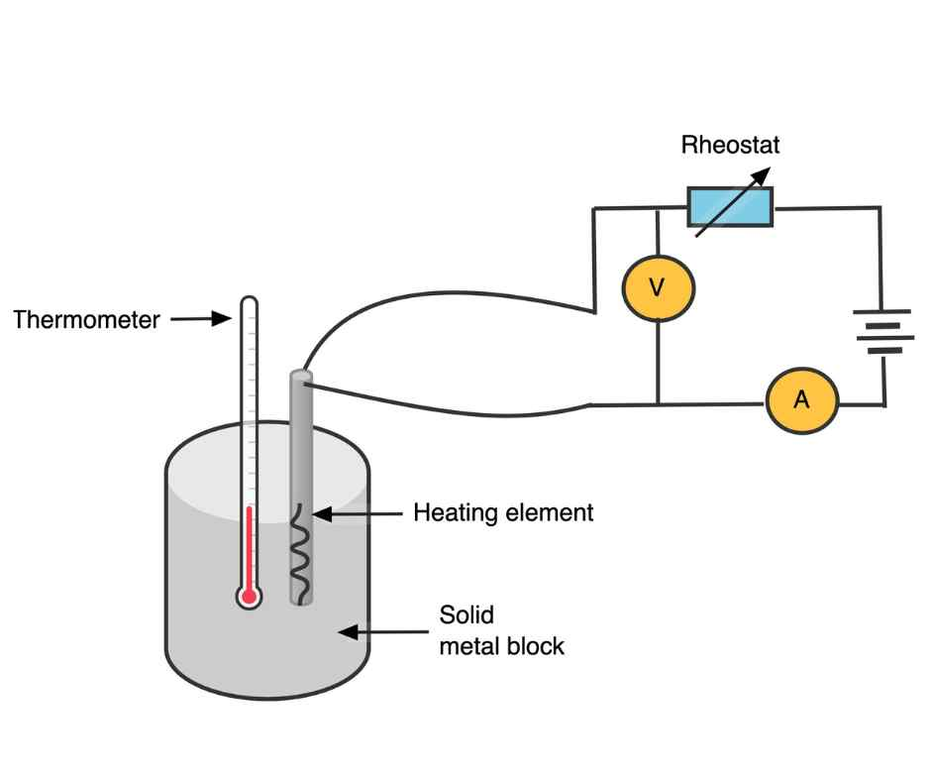

**Note: Read the book to understand the step by step detail for both methods.**

**Transfer of Heat**

Heat transfer occurs due to the 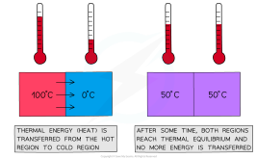

difference in temperature

between two objects, and this

transfer continues until the

objects have reached the same

temperature, known as Thermal

Equilibrium. There are three

methods of Heat Transfer,

conduction, convection and radiation.

***1. Conduction***

Conduction is the method of heat transfer due to collisions of atoms or molecules and motion of free electrons in solids from its hot part to its cold part.

***Detailed Explanation:***

● In solids, atoms and molecules are tightly packed and cannot move freely.

● When one part of the solid is heated, its particles gain energy and begin to **vibrate faster**.

● These vibrations are passed on to neighboring particles through collisions.

● The heat energy thus travels from the hot region to the cold region.

● **Metals** are good conductors because they contain **free electrons** that move rapidly and carry energy efficiently from one part to another.

**Example:** 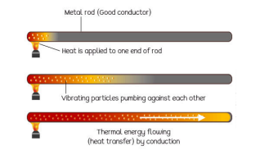

● A metal spoon in hot tea

gets warm at the other end

even though it is not in

direct contact with the

liquid.

**2. Convection**

Convection is the transfer of heat through the **bulk movement of fluid particles** (liquids or gases) from a warmer area to a cooler one.

***Detailed Explanation:***

● In fluids, particles are free to move.

● When fluid near a heat source is warmed, its molecules **move faster**, spread apart, and the fluid becomes **less dense**.

● This warm, lighter fluid rises while **cooler, denser fluid sinks** to take its place.

● This continuous cycle forms **convection currents**.

● These currents are responsible for transporting heat, oxygen, and nutrients in fluids.

**Example:** 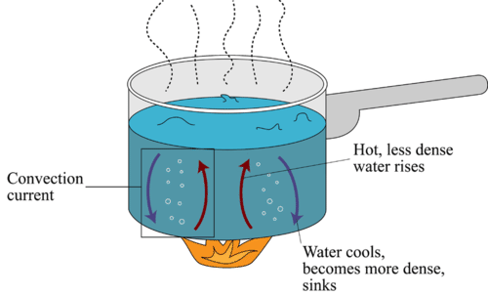

● Heating water in a pot: water at the bottom heats up, rises, and is replaced by cooler water from above, creating a

convection current.

**NATURAL EXAMPLES INVOLVING CONVECTION**

**a. Marine Life (Food, Oxygen, Heat Distribution):**

● Sun heats the surface water → warm water rises → deep, cooler water rich in oxygen and nutrients rises to replace it.

● This circulation supports marine life by distributing heat, food, and oxygen.

**b. Sea Breeze and Land Breeze:**

**Daytime (Sea Breeze): Land heats faster → warm air rises → cooler sea air moves in to replace it (from sea to land).**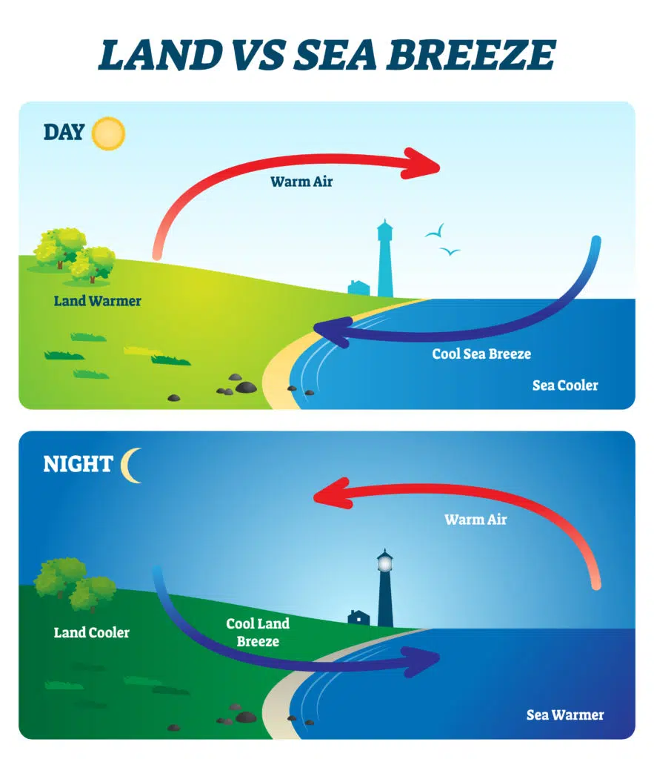

**Nighttime (Land Breeze): Land cools faster → warm sea air rises → cooler land air moves in to replace it (from land to sea).**

**c. Thermals and Bird Flight:** 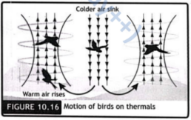

● Sun heats ground unevenly → warm air above hot areas rises → birds glide on these **rising columns of air (thermals)** to conserve

energy.

**d. Hurricanes and Cyclones:**

● Warm ocean water heats air above → warm moist air rises → cooler air rushes in → creates **powerful spinning convection currents**.

● Earth’s rotation causes the spinning → cyclone or hurricane forms.

**3. Thermal Radiation**

Thermal radiation is the transfer of heat in the form of **infrared waves** (electromagnetic waves) without the need for a medium.

● It can occur in **vacuum**, unlike conduction and convection.

● All objects emit thermal radiation depending on their temperature.

***Effect of Surface Properties on Radiation:***

**a. Colour:**

❖**Black surfaces** are the best **emitters and absorbers** of radiation.

❖**White or shiny surfaces** are **poor emitters and poor absorbers**.

**b. Texture:**

● **Dull/matte surfaces** radiate and absorb heat more effectively than shiny or smooth surfaces.

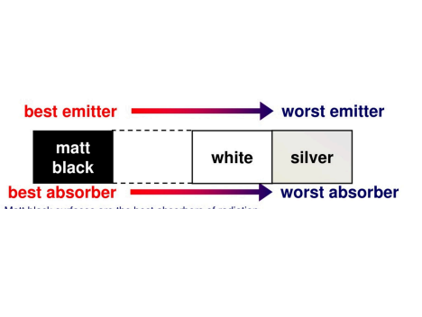

● **Polished surfaces** reflect radiation and emit less heat.

**c. Surface Area:**

★A larger surface area increases the **rate of radiation**.

★More area = more energy radiated per second.

***Effect of Temperature on Rate of Radiation:***

● The **higher the temperature**, the **greater the rate of radiation**.

● Hotter objects emit more infrared radiation.

● The energy radiated increases rapidly with temperature.

**The Leslie Cube**

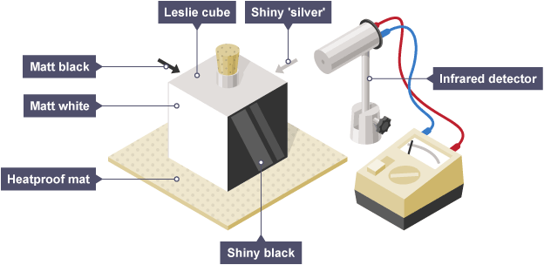

*Purpose:*

To demonstrate how different surfaces emit heat radiation at different rates.

*Apparatus:*

● A **Leslie cube** (metal container with four different surfaces: black, white, shiny, and dull) filled with hot water.

● An **infrared detector** or **thermopile** to measure emitted heat from each surface.

*Observation:* The **black and dull surfaces** emit more radiation than shiny or white surfaces. It also confirms that surface colour and texture affect thermal radiation.

**The Greenhouse Effect**

*The greenhouse effect is the process by which* ***certain gases in the Earth’s atmosphere trap heat****, keeping the planet warm enough to support life.*

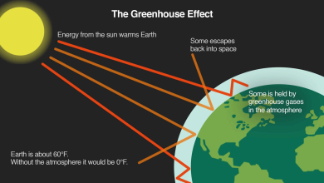

**How it Works:**

The Sun’s rays enter Earth’s atmosphere, and the Earth’s surface absorbs the heat and radiates it back as **infrared (IR) radiation**. **Greenhouse gases** (CO₂, CH₄, H₂O vapor, N₂O) absorb some of this radiation and trap it.

This keeps Earth’s average temperature around 15°C.

**Consequences of Greenhouse Effect**

***Global Warming:***

Global warming is the **gradual increase in Earth’s average temperature** due to excess greenhouse gases caused by human activities.

**Causes:**

● Burning fossil fuels (coal, oil, gas)

● Deforestation

● Industrial emissions

● Agriculture and livestock (methane release)

**Effect:**Increased greenhouse effect → more heat trapped → rising global temperatures.

***The Environmental Effects of Global Warming:***

**a. Flooding:**

● Melting glaciers and polar ice raise sea levels.

● Heavier rainfall causes rivers to overflow.

● Coastal and low-lying areas face more frequent and severe floods.

**b. Hurricanes and Cyclones:**

● Warmer ocean waters provide more energy for storm formation.

● Leads to more **frequent**, **stronger**, and **longer-lasting** hurricanes and cyclones.

**c. Increased Rainfall:**

● Warmer air holds more water vapor.

● This leads to **heavier and unpredictable rainfall**, causing floods and soil erosion.

**d. Droughts:**

● Some regions get less rainfall due to disrupted weather patterns.

● High temperatures cause **faster evaporation** of water.

● Crops fail, water sources dry up, leading to **severe droughts**.

**e. Wildfires:**

● Higher temperatures and longer dry periods dry out forests and grasslands.

● Even small sparks can start **massive wildfires**. ● More frequent and intense wildfires are seen worldwide.

**f. Winter Storms:**

● Global warming affects **jet streams** which can bring **extreme cold weather** and heavy snow to places not used to it. This leads to severe **winter storms** in some areas despite global warming.

***GEOTHERMAL HEAT FLOW***

**1. Structure of the Earth (from outside to inside):** ● **Crust:** Thin outer layer (solid rock, ~5–70 km thick)

● **Mantle:** Semi-solid layer of hot rock (~2,900 km thick)

● **Outer Core:** Liquid iron and 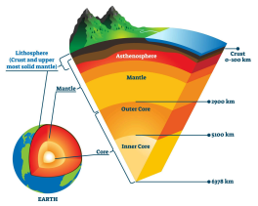

nickel (generates magnetic

field)

● **Inner Core:** Solid iron and

nickel (very high pressure

and temperature)

*The Flow of Heat in Geothermal Activities:*

● **Heat from the Earth's interior flows outward** to the surface.

● This heat moves through the mantle by **convection** and through the crust by **conduction**.

● **As the hot magma rises**, cooler material sinks, creating **mantle convection currents** that drive the tectonic plate movement and volcanic activity.

➢**The Flow of Magma and Volcanic Eruptions:**

In volcanic regions, magma rises through cracks in the crust. When **pressure builds up**, magma is forced out, causing a **volcanic eruption**.This magma carries intense **thermal energy** from deep inside Earth to the surface, which causes volcanic eruptions to release heat, gases, and molten rock.

➢ **Movement of Tectonic Plates:**

**The Earth’s crust is divided into tectonic plates** floating on the semi-fluid mantle. There are convection currents in the mantle (caused by internal heat) which drive the **slow movement** of these plates. Their interactions cause **earthquakes, mountain formation**, and **volcanic activity**.

***Earth's Core and Internal Heat Sources:***

The Earth's interior remains hot due to:

**a. Residual Heat from Formation:** Heat left over from the planet’s formation (4.5 billion years ago) due to collisions and compression.

**b. Radioactive Decay:** The natural decay of radioactive elements (like uranium, thorium, potassium) in the mantle and crust releases heat continuously.

**c. Gravitational Compression (Core Formation):** As heavier elements (like iron) sank to the center during Earth’s formation, **gravitational energy** converted into heat.

**Crust as an Insulator:**

The **crust is a poor conductor of heat**, so it acts as an **insulating layer**. This slows down the escape of heat from the interior to the surface, and as a result, the Earth's core remains

extremely hot even today.